Regulatory Agencies

FCC

CSPC (Consumer Product Safety Commission)-

Steps in a criminal trial

Arrest

Preliminary Hearing

Indictment

Arraignment- 2 choices guilty or innocent

Trial

Acquittal

(or)

Sentencing

TYPES OF LAW

Common

Civil

Criminal

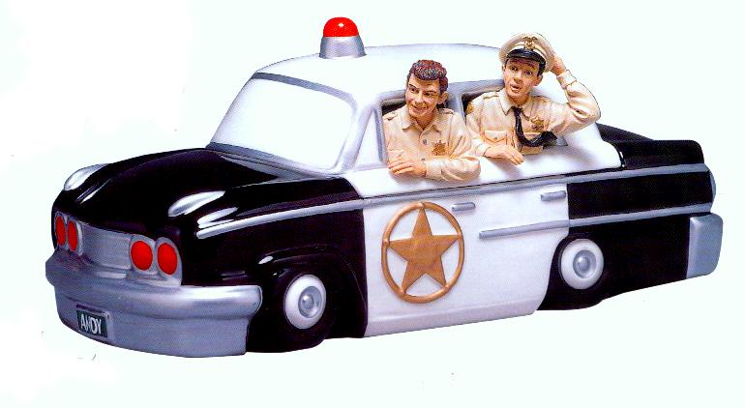

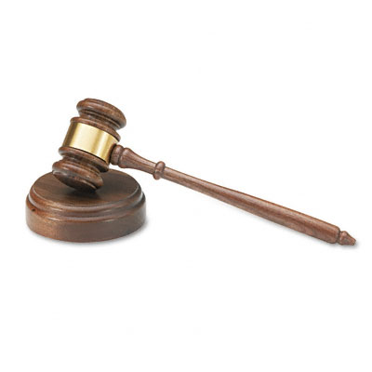

CIVIL TRIAL STEPS

1: Plaintiffs attorney files a ____________.

2: The Court sends a _____________ to the defendant.

3: Decedents attorney files an answer

4: Pleading documents are exchanged

5: Pretrial hearings are held to see if both sides can reach a _______________.

6: __________ (if no compromise is met in pretrial).

7: Verdict- IF

Defendant wins-

Plaintiff wins-

TYPES OF PUNISHMENT

Suspended sentence

Community service

Parole

Home imprisonment

Fine

Work release

Juvenile detention (kids only)

Boot Camp (normally kids only)

Prison

*CIVICS EOC REVIEW GOAL 6*