TOWN TERMS

Town Meeting

Annexation

Zoning

BILL TO LAW STEPS

1: A person comes up with an __________.

2: A Senator (or Representative) decides to

______________ the bill and has it written

3: The bill is ________________ on the floor

4: Bill is given a ______ and assigned to a

_________________

5: The committee ________ the bill and holds

Public ________________

6: The bill is sent to the full Senate (or house if it starts there for a _______________.

7: It is approved where it goes to the other house. The process __________________.

8: It is approved and goes to the _____________ to be signed into law.

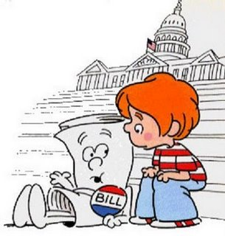

TERMS

Judicial Independence

Hung Jury

Plea Bargain

Town Meeting

Congressional Committee Types

Standing

Joint

Select

Conference

TYPES OF JURISDICTION

Original

Appellate

Concurrent

Exclusive

FEDERAL COURT LEVELS

*CIVICS*

*EOC*

*REVIEW*

*GOAL*

*5*