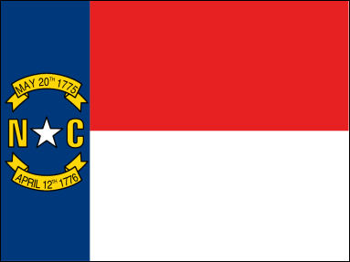

3 Branches of State Government

Legislative

___________ Laws

Example:

Executive

___________ Laws

Example:

Judicial

___________ Laws

Example:

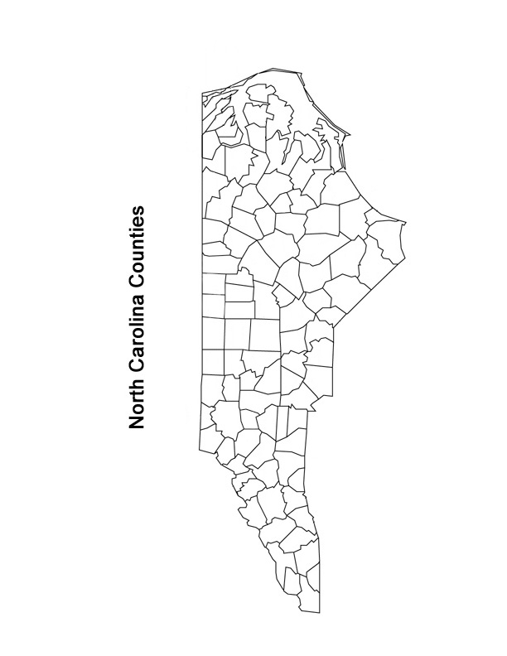

State/ local revenue

Most $ comes from state ________________ taxes.

Other forms are sales, income, property taxes, licenses, permits, user fees, and federal grants.

State/ Local Spending

Most money is spent on school and jails.

Money also spent on health, libraries, parks, elections

Local Government

County

City

Special (school) districts

Townships

Metropolis

Terms:

Incorporation

Charters