Terms-
Magna Carta-

Mercantilism-

CIVICS EOC REVIEW
GOAL ONE
COLONIAL DIFFERENCES

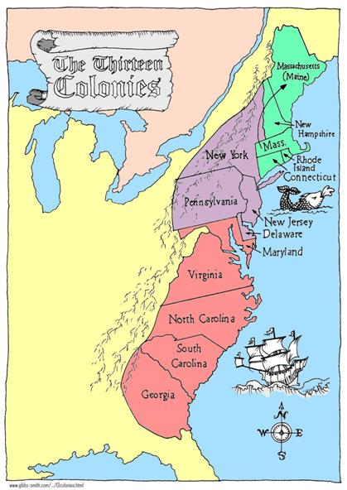

New England-

Middle-

Southern-

Democracy

House of Burgesses Mayflower Compact
(Representative) (Direct)

Enlightenment Philosophers-

John Locke-

Montesquieu-

Rousseau-

Battles
Of
The
Revolutionary
War

Trenton

Saratoga

Guilford Courthouse

Yorktown

Causes of the Revolution:

1: No taxation without representation (on back)
2: Discontent wit British Rule
3: Desire for self government/ Liberties
4: Mercantilism (see above)
5:Lexington and Concord
6: Common Sense (Paine)
Constructional Convention-
Meeting to change the Articles turned into making a new Constitution
Compromises:

Great (Connecticut)-
(Combination of NJ and VA plans)-

______ Houses (bicameral)
Upper by ______________
Lower by ______________

3/5TH- Slaves counted as ________

Why?
7: Declaration of Independence
Written by:
Ideas
Ratification debate:

Federalists

------------ VS. ----------

Anti-Federalists
Social Compact-

Natural (inalienable) rights-
Article of Confederation-
First attempt at government

Weaknesses

