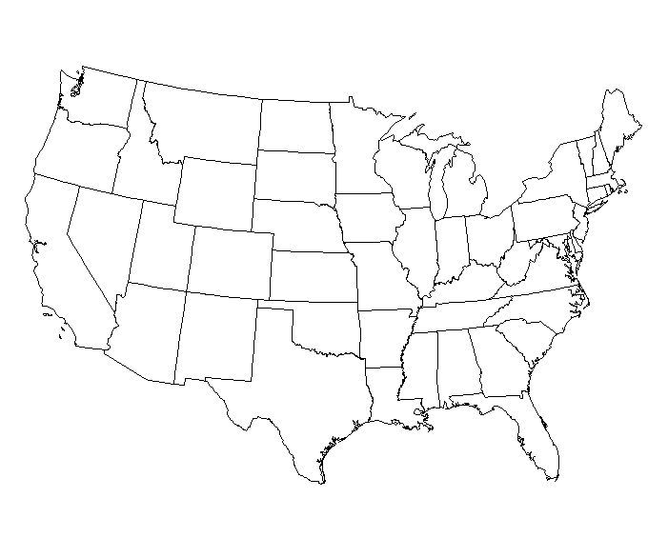

Checks and Balances

|  |  |  |  |
| --- | --- | --- | --- |
|  | Leg. | Exec. | Jud. |
| Leg. | X |  |  |
| Exec. |  | X |  |
| Jud. |  |  | X |

AMENDMENTS:

1

2

3

4

5

6

7

8

9

10

Bill of Rights-________________________

___________________________________.

Added so the _________________ would approve the Constitution.

CIVIL WAR AMENDMENTS

13

14

15

SUFFRAGE (VOTING) AMENDMENTS

15

19

23

24

26

PROHIBITION

18

21

TERMS

Impeachment-

Judicial Review-

States- Rights-

Government Revenue-

Government Agencies-

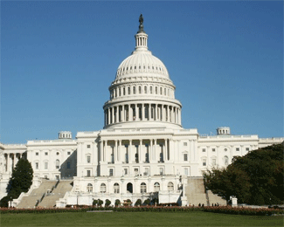

CIVICS EOC REVIEW

GOAL TWO PART ONE